### Querying to Find Children to Export

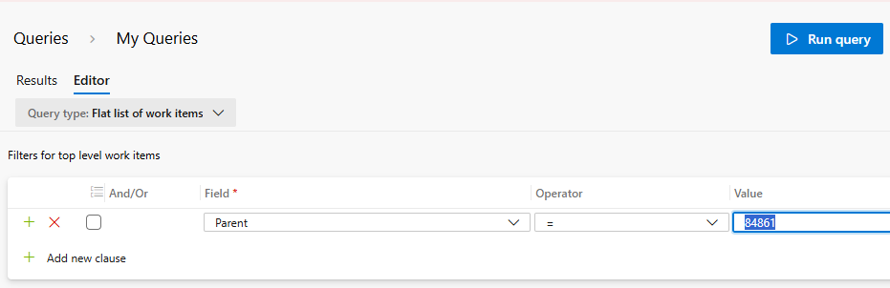

Set the value of parent to the ID of the backlog item (or other task) to get a list of children. Then click “Export as CSV” to get the information

### Querying to Get Existing Parent Info to Export



Simply fill in the Title Field with the title of the item you want to export, or the ID Field with the id of the item you want to export, etc. Then click “Export as CSV”

### Modifying the Data in Excel

1. Upload the Children data into Google Drive and open in Excel
2. Delete the IDs from all the children tasks
3. Rename the Title column to “Title 2” for the tasks
4. Add a “Title 1” column for the existing Parent
5. Copy/paste the Parent data from the exported csv file into this excel

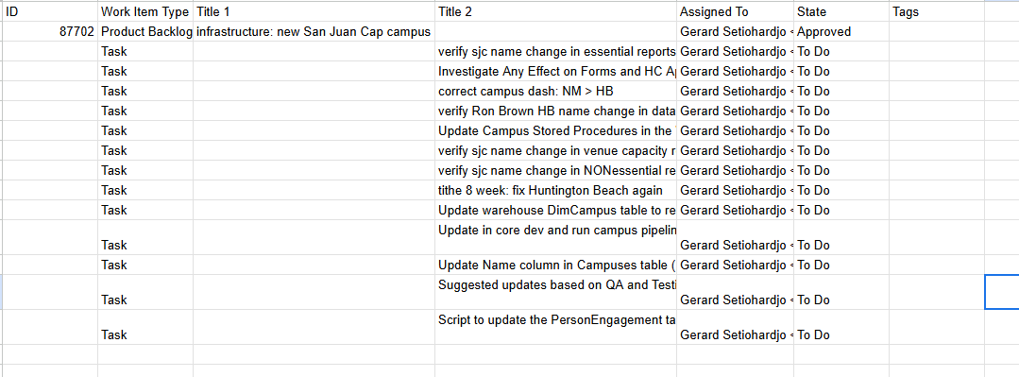

### Importing New Data into DevOps

1. Download the modified Excel as csv
2. Go to DevOps Queries and click “Import Work Items”
3. Import the downloaded csv file